<EMPTY>

**Our Mission**

This nonprofit organization, founded in 1975, works to strengthen the diverse human community through the promotion and practice of nonviolence and understanding.

**Our Goals**

The volunteer members of the MLK Coalition strive to fulfill that mission by keeping Dr. King’s memory and ideals alive through the annual program and related activities.

**Our Work**

The MLK Coalition works year-round to promote Dr. King’s Legacy with annual MLK Day events and other programs.

The Commemorative Civil Rights March begins at the Freedom Center and proceeds to Washington Park or a closing interfaith prayer service.

The Commemorative Program at Music Hall follows the March, and includes music by the award-winning MLK Coalition Chorale.

All events ar

**For more information, contact:**

MLK Coalition

PO Box 19358

Cincinnati, Ohio 45219

Visit our website: www.mlkcoalition.org

Or email: mlkcoalition@gmail.com

Follow Us on:

Twitter @MLKingCoalition

Instagram @MLKCoalition

www.facebook.com/MLKCoalition/

**MLK Coalition Board of Directors, 2022-2023**

**Officers**

Raffel Prophett, President

Rabbi Gary Zola, President Emeritus

Eric Watford, Vice President

Dr. Martha Viehmann, Secretary

George Ten Eyck, Treasurer

**Board Members**

Members of the MLK Coalition are the Board of Directors. Many members represent area organizations and

religious communities. Others are members-at-large who are dedicated

to the mission of the Coalition.

**Membership Information**

**About the MLK Coalition**

**The Martin Luther King, Jr. Coalition**

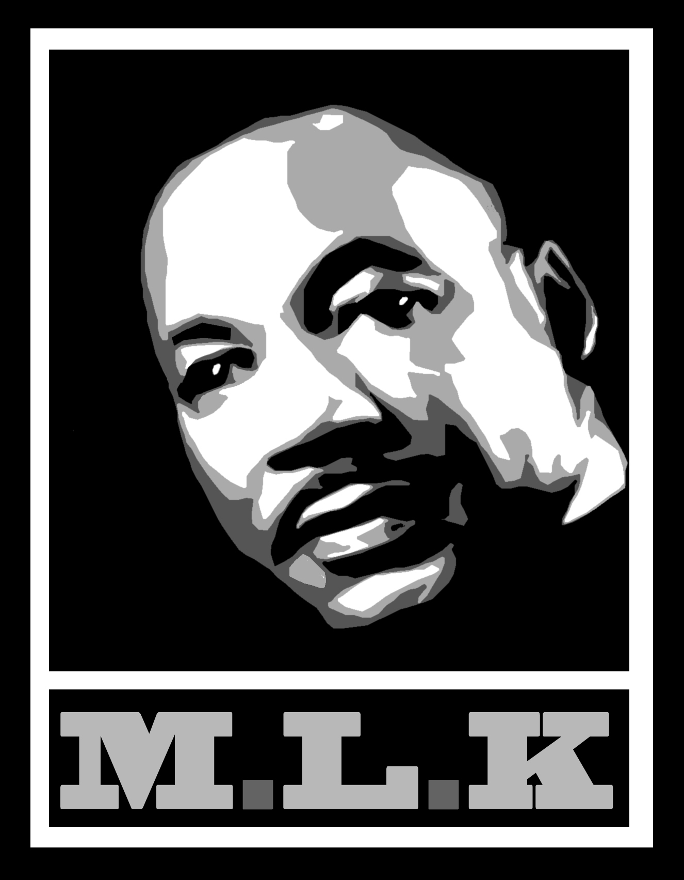

<EMPTY>

* **Membership Responsibilities**
* All members promote the mission and work of the MLK Coalition by keeping Dr. King’s legacy alive and vibrant, promoting respect for diversity, mutual understanding, and nonviolent social change. This commitment will be evident in the atmosphere of respect and understanding at all meetings and events.
* Active members participate each year in the work of the Martin Luther King, Jr. Coalition in

various ways:

* + attending regular meetings
  + working with a committee
  + working on MLK Day toward

the success of the events

* Each planning year begins in March and concludes the next February with the meeting to evaluate that year’s MLK Day events. New members may join at any time during the year. They are asked

to work through the end of the planning year.

* **Special Recognition**

Lifetime membership status will be established by the Board for members who have played a vital role in the MLK Coalition but are no longer able to participate actively or attend regular meetings.  Active members are invited to lift up names for this honor for approval by the Board.

* **How to Become a Member**
* Anyone interested in joining the MLK Coalition is asked to attend three meetings as a guest during

a six-month period to get to know our work and our membership.

* After attending the third

meeting, guests can become active, voting members by notifying the president and the secretary of their intent to join.

* Membership is ongoing from year

to year based on continued participation.

***The Martin Luther King Jr. Coalition is committed to keeping Dr. King’s***

***legacy vibrant in Cincinnati.***

***The Martin Luther King Jr. Coalition welcomes new members. Membership in the MLK Chorale is also open. Email mlkchorale.cincy@gmail.com***

***Please read our Membership Information to learn more about joining the MLK Coalition.***

* The opportunity to work toward a common goal with a diverse group of people committed to Dr. King’s legacy
* Participation in planning the City of Cincinnati’s premier MLK Day celebrations
* Monthly notifications of meetings, including minutes, agendas and other periodic information
* Access to periodic opportunities made available to Coalition members
* Listing of name and organization, if appropriate, in the program book and on the website
* Affiliation with the MLK Coalition Library Fund which provides funding to the Public Library of Cincinnati and Hamilton County for the purchase of materials about Dr. King and his legacy
* Box-seating at Music Hall on MLK Day
* **Benefits of Membership**